I. Table of Contents
1 Introduction 2
1.1 Purpose 2
1.2 Scope 2
1.3 Server Requirements 2
2 Installation Manual 2
2.1 Pre-requisites 2
2.2 Pre-installation Tasks 3
2.3 Installation Procedure 3
2.3.1 Initial File Setup 3
2.3.2 Database Setup 4
2.3.3 Running installation scripts 5
2.4 Post-installation 9
3 Additional Information 10
3.1 Document Revisions 10
3.2 Reference Documents 10

Introduction

Purpose
This document is provided to serve as installation guidelines for the Drupal 7 Content Management System.
The objective of this document is to set up a functioning Drupal 7 base installation.

An inadequate, incomplete or inexistent install procedure may lead to
website instability and data loss. Check prerequisites and pre-install checklist before proceeding.

Scope
This document is intended to direct and assist a novice user with the detailed set-up of the Drupal 7 Content Management System.
It will not cover detailed aspects such as module and theme installation, Drupal Core configuration, or updates to themes, modules, or the Drupal Core environment.

Server Requirements
To install and run Drupal 7, the following requirements must be met: [1]
- Apache version 2.0 or greater
- PHP 5.2.0 or greater
- MySQL 5.0 or greater, PostgreSQL 8.3 or greater, or SQLite 3.4.2 or greater

Failure to meet these requirements will cause installation failures or a non-operable installation of Drupal 7.

Installation Manual

Pre-requisites
Before beginning the installation of Drupal 7, verify that the following are available and configured for use:
- Web server (Must meet server requirements outlined in section 1.3)
- FTP Software
- Stable internet connection
- Any archive software (WinRAR, 7-zip, etc)
- Any text editor
- Web browser with internet access

Pre-installation Tasks
Before installation, visit www.drupal.com/start and download the latest release of Drupal 7. It will be available for download as a tar.gz or a zip file. Either will work, but some archive managers only support the zip format. Refer to your software manual to determine which file format(s) are supported.
For the purposes of this installation it is going to be assumed that there is an active domain and an empty directory available and properly configured to host this website.

Installation Procedure

Initial File Setup
- Extract the installation files from the archive using your archive manager.
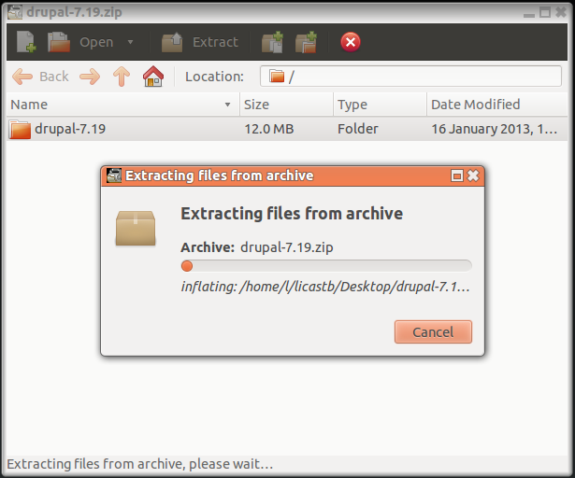
- Move the extracted files into a directory within your web servers public HTML directory or document root. [1]
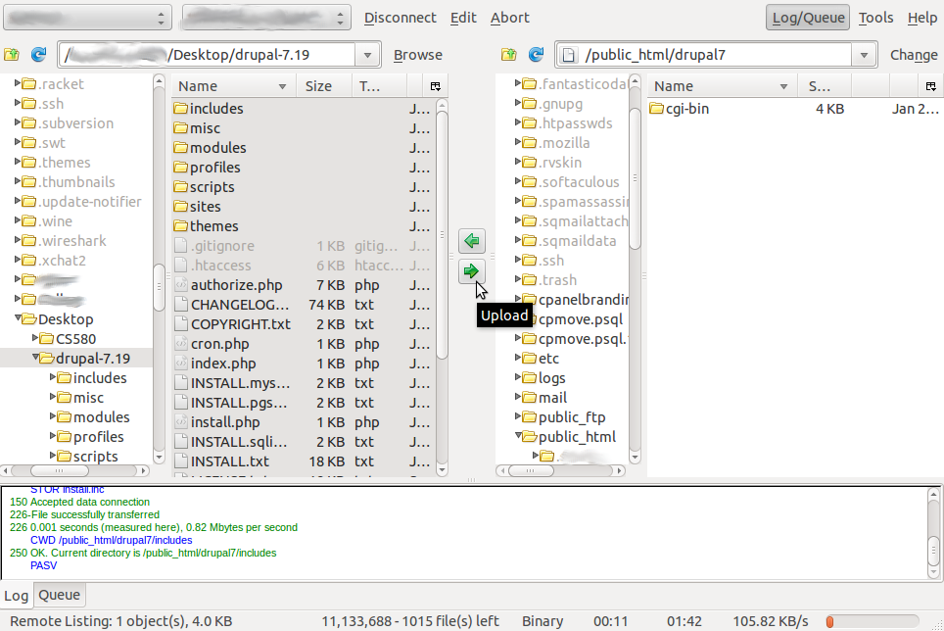
- Create a configuration file by copying the example, named default.settings.php (located in the sites/default directory of the extracted files). Rename the copied file to settings.php. [1]
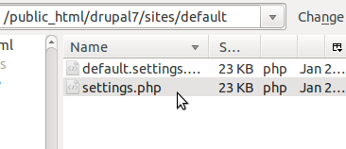
- Give the web server write privileges (644) for the settings file. [1]
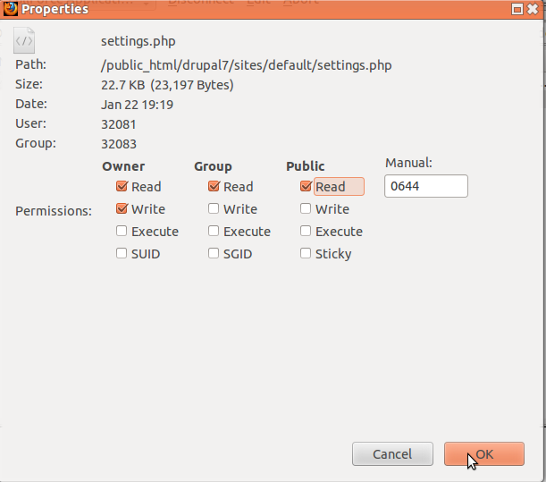
The file work has been completed for this tutorial. Feel free to modify the .htaccess file for your needs, install/remove modules and themes, etc. This is all we will be covering in this tutorial.

Database Setup
To set up a database for your Drupal 7 installation, log in to your database management software of choice. For this installation walk-through we will be using the integrated Cpanel database tools.
- Create the database and password using your database management tool.
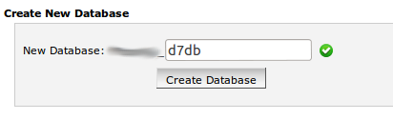
- Next you will have to set database access permissions. Open your user permissions dialogue and give the database user access for the following:
SELECT, INSERT, UPDATE, DELETE, CREATE, DROP, INDEX, ALTER
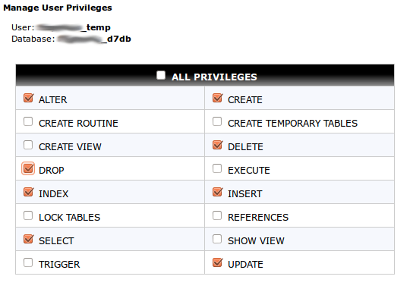
You have successfully created a database and user at this point. If the privileges have been set successfully move on to section 2.3.3 – running the install scripts.

Running installation scripts
To run the Drupal 7 installation scripts open a web browser and navigate to the web address of your new Drupal installation. (ex. www.example.com ) You should see a page that looks similar to the one below.

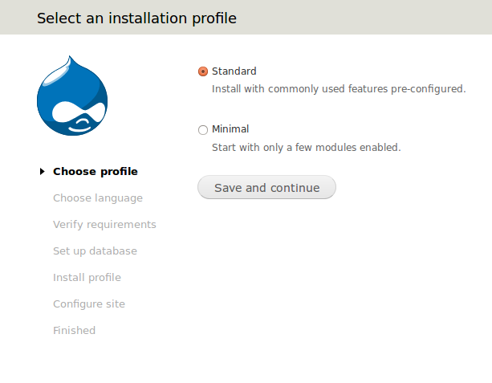
We are going to use the standard settings for this installation. Click save and continue.

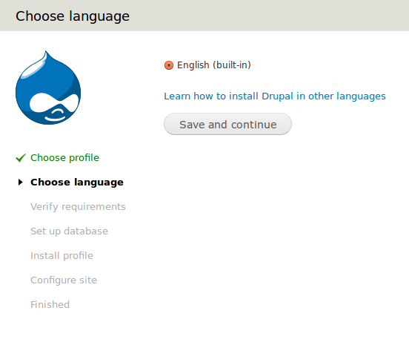
English is the only language offered natively so we will use that. Click Save and continue to move to the next page.
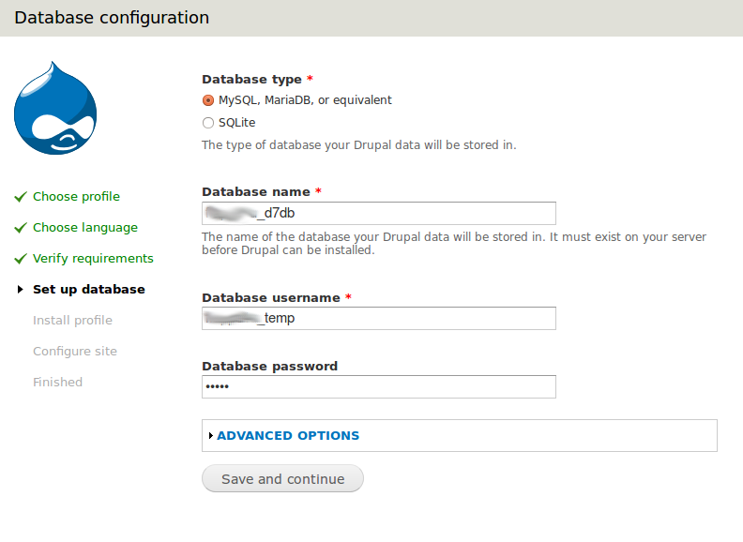
This is where the database name, username, and password will be set up. Enter them in the appropriate fields after selecting the database type you will be installing Drupal on. Advanced options are fine as the default values in a majority of situations. Click Save and continue to move to the next step.

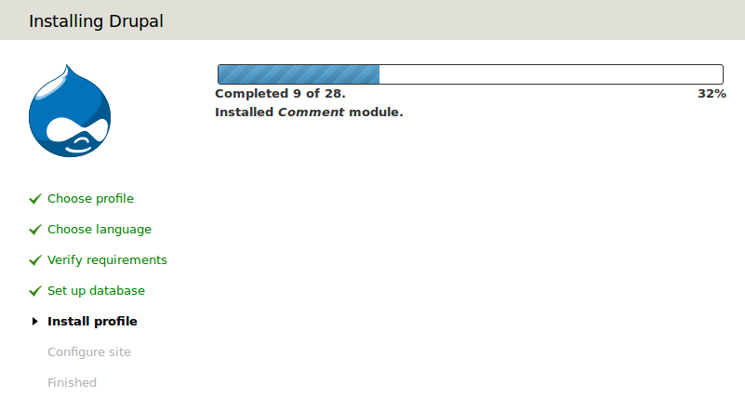
After clicking the Save and continue button Drupal should be able to connect to the database successfully and will proceed with the installation and default module configuration. You should see something similar to the image below.

After set up has finished you will be presented with a rather lengthy page asking for some information. I have broken the descriptions into sections to keep the monotony to a minimum.
- Site Information
  - Site name – The name that will appear in the header of the Drupal website.
  - Site e-mail address – Email address that all emails will be sent from
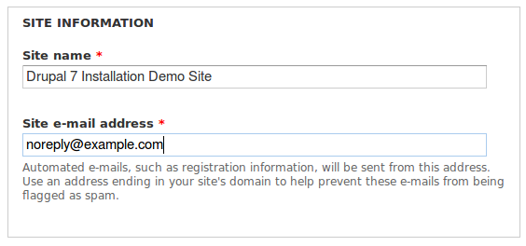
- Site Maintenance Account
  - Username – The root account's login. Used to perform admin functions
  - Email address – Email for the root user

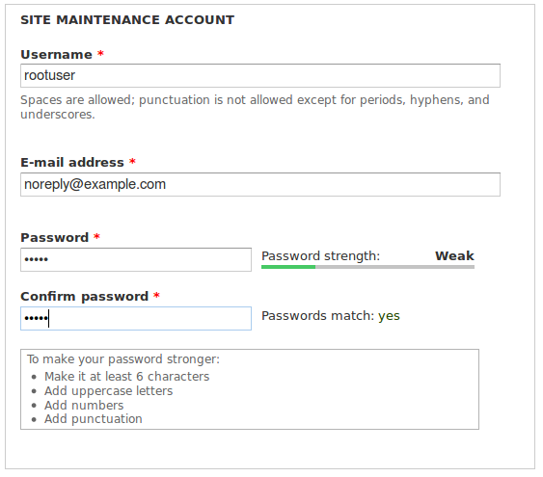
- Server Settings
  - Default Country – Choose the country that will be selected by default when new users register. Also usually the geographic location of the site.
  - Default time zone – Default time zone for new users and date stamps
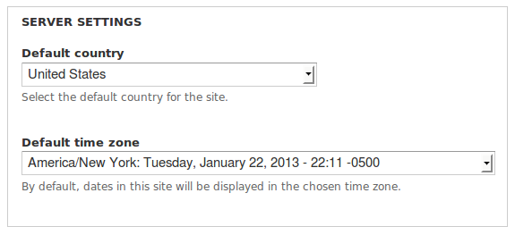
- Update notifications are personal preference. After selecting the options you want, click Save and continue as shown in the image below.
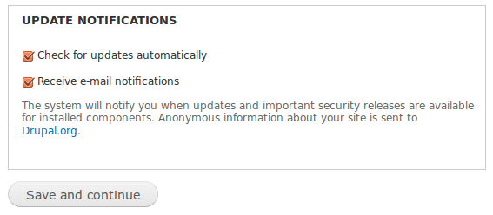
- If everything was properly filled out and configured, you should see the success message listed below.

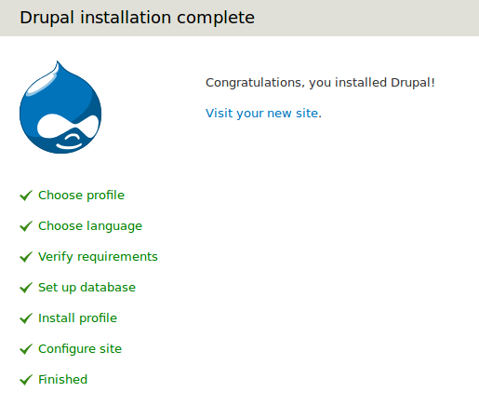
Post-installation
If everything went well and you clicked the “View your new site” button on the previous screen, your new website should look something like this:
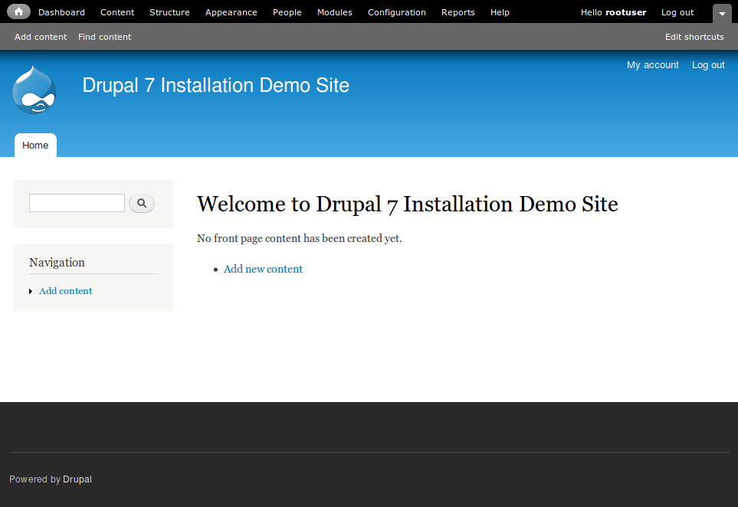
At this point you can rest assured that everything is installed, and if there are no errors displayed it has been set up and configured correctly. From here you can post content, manage your website, etc. Log out and you will see the site as the public would.
Congratulations and job well done!

Additional Information

Document Revisions
Date * Revision Number | Description
1.20.2013 * 1.0 | Document initially created.
1.22.2013 * 1.5 | Changed formatting and added database directions.
1.23.2013 * 1.5.1 | Fixed auto correct typo and several minor grammatical errors.

Reference Documents
[1] Sea, Eric. "Quick Install for Beginners." Drupal. Drupal.org, 13 Aug. 2012. Web. 22 Jan. 2013. <http://drupal.org/documentation/install/beginners>.

